Research 2.0: APA as an All-in-One Personal Assistant
The 12 research papers, their links, and what each one means for our project. In each screenshot, yellow highlights mark the findings relevant to APA.
Papers 1-11 are from our Literature Review Reference Table (research/ADA_V2_Literature_Review_Matrix.xlsx); paper 12 is new, found to confirm that 'all-in-one personal assistant' research exists. Checked against the abstracts; read the full papers before quoting numbers.

Quick guide: which paper is which
# | What APA does | Paper | Link
1 | Talks naturally (voice) | Moshi (2024) | https://arxiv.org/abs/2410.00037
2 | Does tasks by voice | GPTVoiceTasker (2024) | https://arxiv.org/abs/2401.14268
3 | Thinks, then acts | ReAct (2023) | https://arxiv.org/abs/2210.03629
4 | Uses tools | Toolformer (2023) | https://arxiv.org/abs/2302.04761
5 | Controls Windows apps | UFO (2024) | https://arxiv.org/abs/2402.07939
6 | Uses a real computer | OSWorld (2024) | https://arxiv.org/abs/2404.07972
7 | Helps without being asked | Meurisch et al. (2020) | https://doi.org/10.1145/3432193
8 | Remembers you | MemGPT (2023) | https://arxiv.org/abs/2310.08560
9 | Stays safe from tricks | Greshake et al. (2023) | https://arxiv.org/abs/2302.12173
10 | Respects privacy | Lau et al. (2018) | https://doi.org/10.1145/3274371
11 | Self-monitoring and reflection | Generative Agents (2023) | https://arxiv.org/abs/2304.03442
12 | All-in-one personal assistant | Personal LLM Agents survey (2024) | https://arxiv.org/abs/2401.05459

1. Moshi: Talks naturally (voice)
Défossez, A., Mazaré, L., Orsini, M., Royer, A., Pérez, P., Jégou, H., Grave, E., & Zeghidour, N. (2024). Moshi: A speech-text foundation model for real-time dialogue [Preprint]. arXiv. https://doi.org/10.48550/arXiv.2410.00037
Link: https://arxiv.org/abs/2410.00037
Full PDF: https://arxiv.org/pdf/2410.00037
What it is | A single AI model that listens and speaks at the same time, instead of the usual speech-to-text, think, text-to-speech chain.
Key finding | First real-time full-duplex spoken model; reply delay about 200 ms, close to human conversation.
Why it matters for APA | APA's voice uses the same idea: Gemini native audio hears and speaks directly, which is why APA feels like a real conversation.

Highlighted abstract:
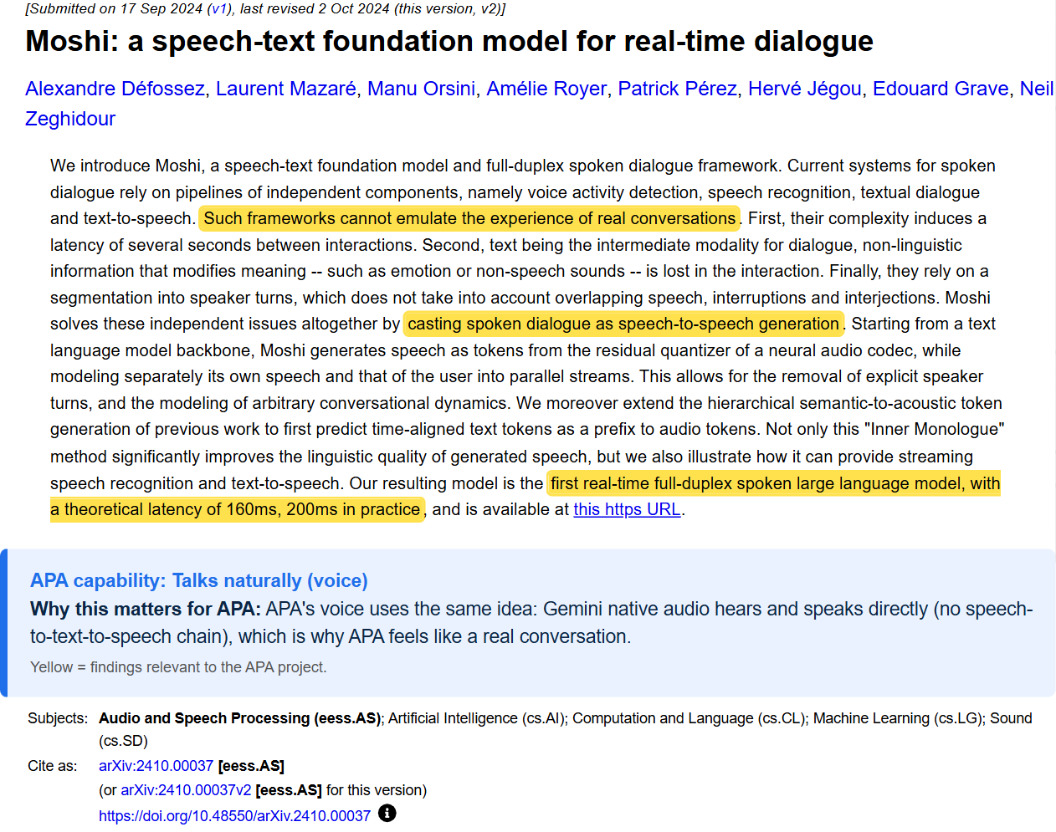

2. GPTVoiceTasker: Does tasks by voice
Vu, M. D., Wang, H., Chen, J., Li, Z., Zhao, S., Xing, Z., & Chen, C. (2024). GPTVoiceTasker: Advancing multi-step mobile task efficiency through dynamic interface exploration and learning. UIST 2024.
Link: https://arxiv.org/abs/2401.14268
Full PDF: https://arxiv.org/pdf/2401.14268
What it is | A voice assistant that taps through phone screens for you and learns from your past commands.
Key finding | Made multi-step tasks 34.85% more efficient in a user study.
Why it matters for APA | Closest match to APA's 'say it and it happens' idea. It works on Android phones; APA does it on a Windows desktop with native voice.

Highlighted abstract:
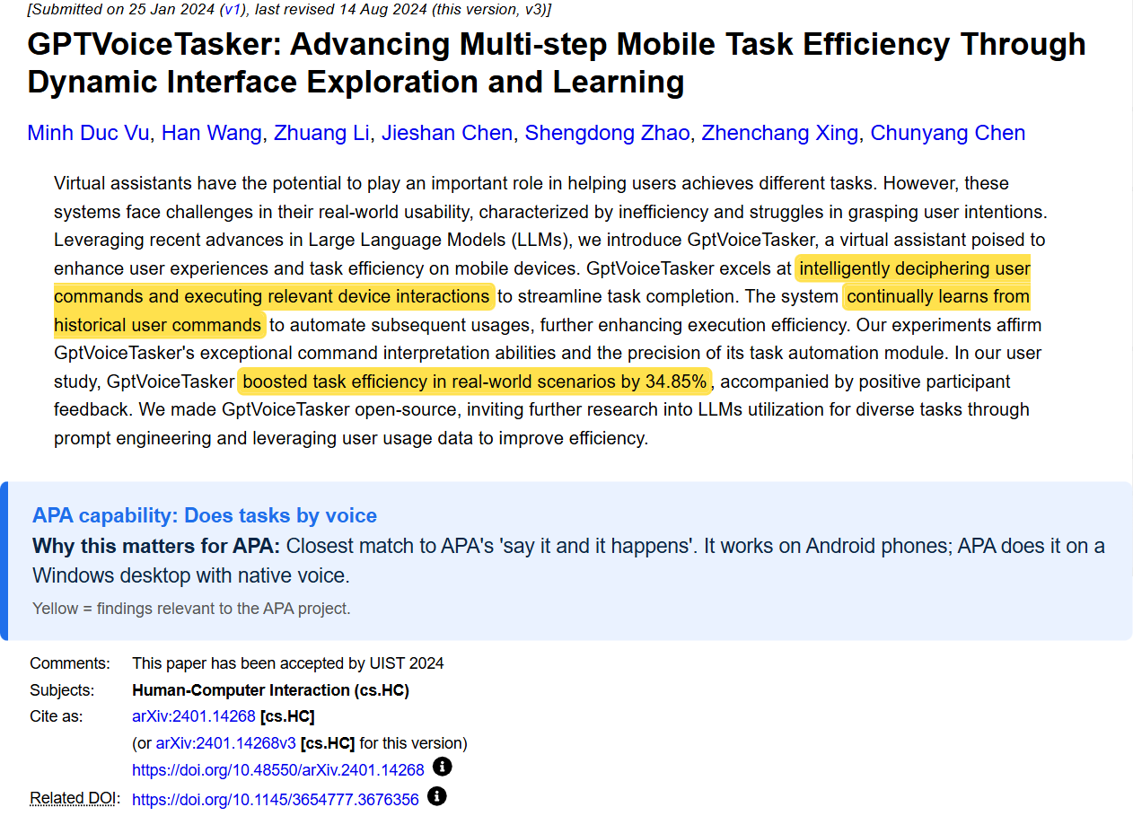

3. ReAct: Thinks, then acts
Yao, S., Zhao, J., Yu, D., Du, N., Shafran, I., Narasimhan, K., & Cao, Y. (2023). ReAct: Synergizing reasoning and acting in language models. ICLR 2023.
Link: https://arxiv.org/abs/2210.03629
Full PDF: https://arxiv.org/pdf/2210.03629
What it is | The AI thinks, takes one action, looks at the result, and thinks again, in a loop.
Key finding | More successful and easier to understand than acting without thinking; +34% and +10% success on two task benchmarks.
Why it matters for APA | APA's computer-control rule 'look first, act one step at a time' is this loop: screenshot, one click, check again.

Highlighted abstract:
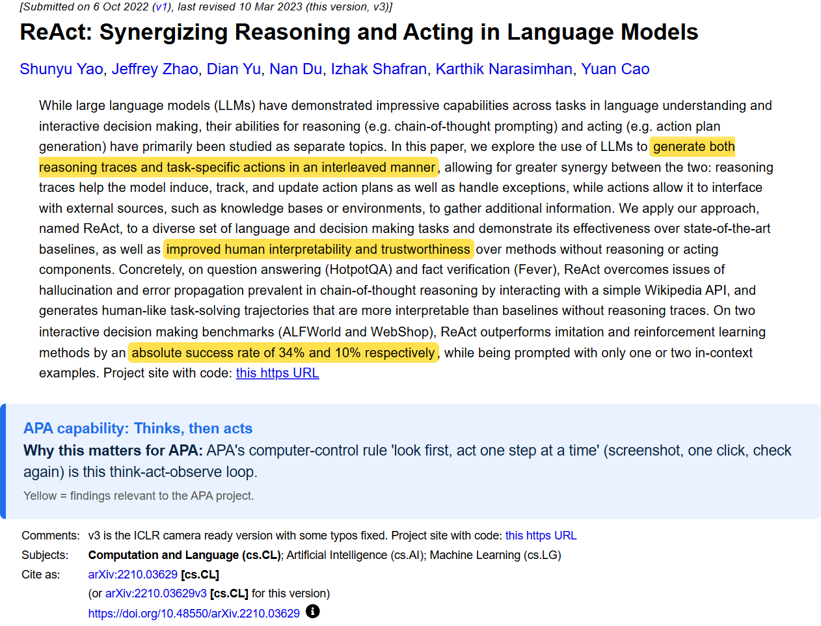

4. Toolformer: Uses tools
Schick, T., Dwivedi-Yu, J., Dessì, R., Raileanu, R., Lomeli, M., Hambro, E., Zettlemoyer, L., Cancedda, N., & Scialom, T. (2023). Toolformer: Language models can teach themselves to use tools. NeurIPS 36.
Link: https://arxiv.org/abs/2302.04761
Full PDF: https://arxiv.org/pdf/2302.04761
What it is | An AI that learns by itself when to call tools such as a calculator, search, translator or calendar.
Key finding | Better at tasks using tools, without losing its normal language skills.
Why it matters for APA | The idea behind function calling. APA has about 20 tools (email, weather, maps, God's Eye, computer control, focus). APA's tools have real effects, so they need safety rules.

Highlighted abstract:
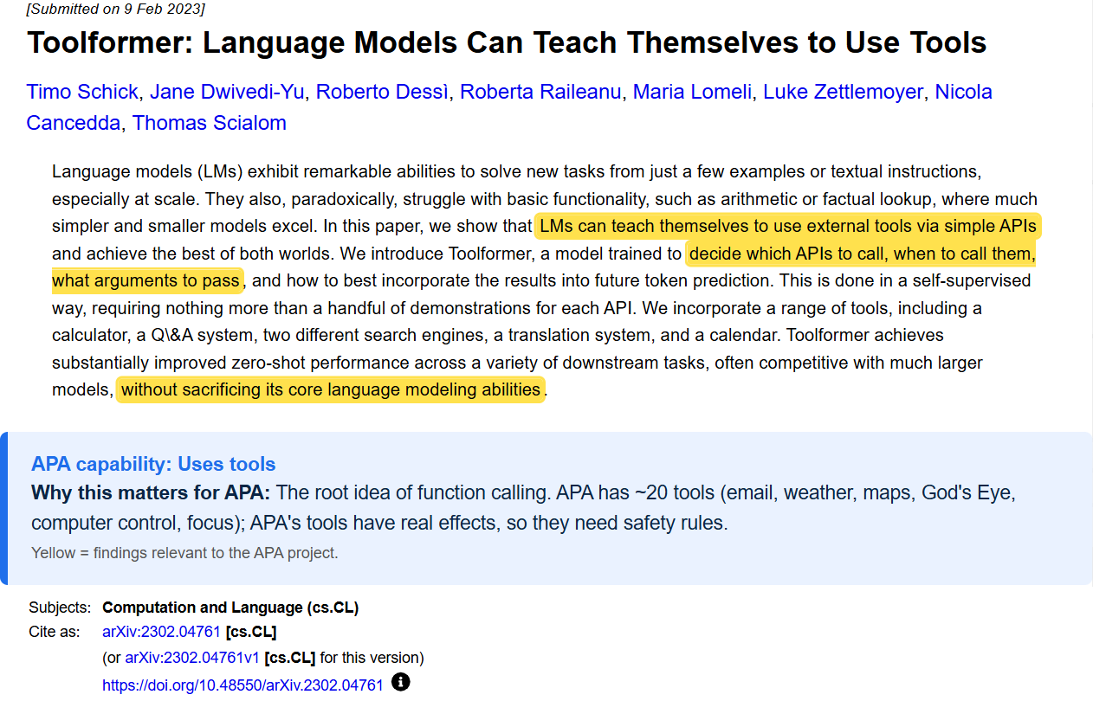

5. UFO: Controls Windows apps
Zhang, C., Li, L., He, S., Zhang, X., Qiao, B., Qin, S., Ma, M., Kang, Y., Lin, Q., Rajmohan, S., Zhang, D., & Zhang, Q. (2025). UFO: A UI-focused agent for Windows OS interaction. In Proceedings of NAACL-HLT 2025 (Volume 1: Long Papers) (pp. 597–622). Association for Computational Linguistics. https://doi.org/10.18653/v1/2025.naacl-long.26
Link: https://arxiv.org/abs/2402.07939
Full PDF: https://arxiv.org/pdf/2402.07939
What it is | Microsoft's AI agent that operates Windows apps for you using screenshots and Windows UI Automation.
Key finding | Completed tasks inside and across 9 popular Windows apps using only natural-language requests.
Why it matters for APA | Closest system to APA's computer control (same Windows UI Automation approach). APA adds real-time voice, the Bluey pointer and an emergency stop.

Highlighted abstract:
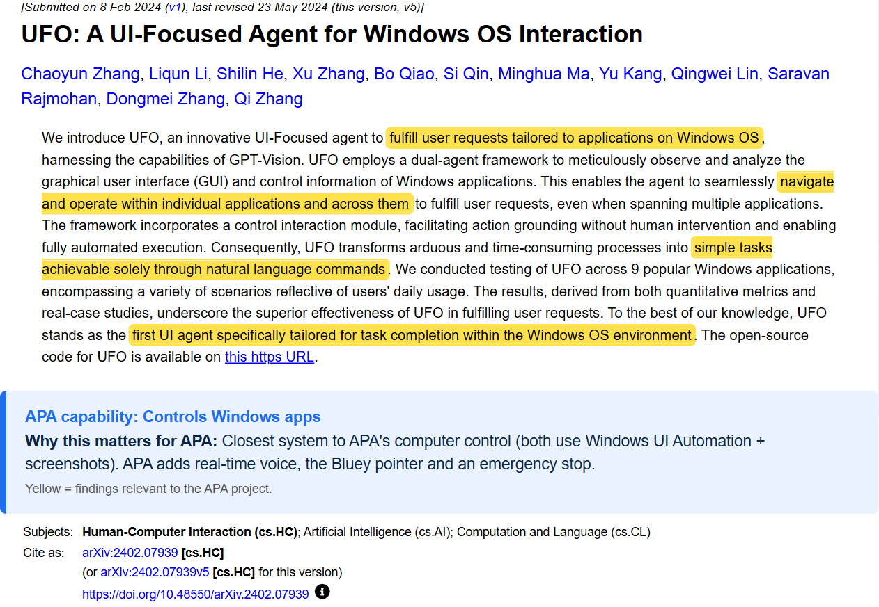

6. OSWorld: Uses a real computer
Xie, T., Zhang, D., Chen, J., Li, X., Zhao, S., Cao, R., Hua, T. J., Cheng, Z., Shin, D., Lei, F., Liu, Y., Xu, Y., Zhou, S., Savarese, S., Xiong, C., Zhong, V., & Yu, T. (2024). OSWorld: Benchmarking multimodal agents for open-ended tasks in real computer environments. In Advances in Neural Information Processing Systems 37 (NeurIPS 2024), Datasets and Benchmarks Track.
Link: https://arxiv.org/abs/2404.07972
Full PDF: https://arxiv.org/pdf/2404.07972
What it is | A test of 369 real computer tasks on Windows, macOS and Ubuntu to see if AI agents can finish them.
Key finding | Humans finished 72.36% of tasks; the best AI only 12.24%. AIs mostly fail at finding the right thing on screen.
Why it matters for APA | Computer control is still hard, so APA keeps a human in the loop and an emergency stop. It also gives APA a fair way to measure its own success rate later.

Highlighted abstract:
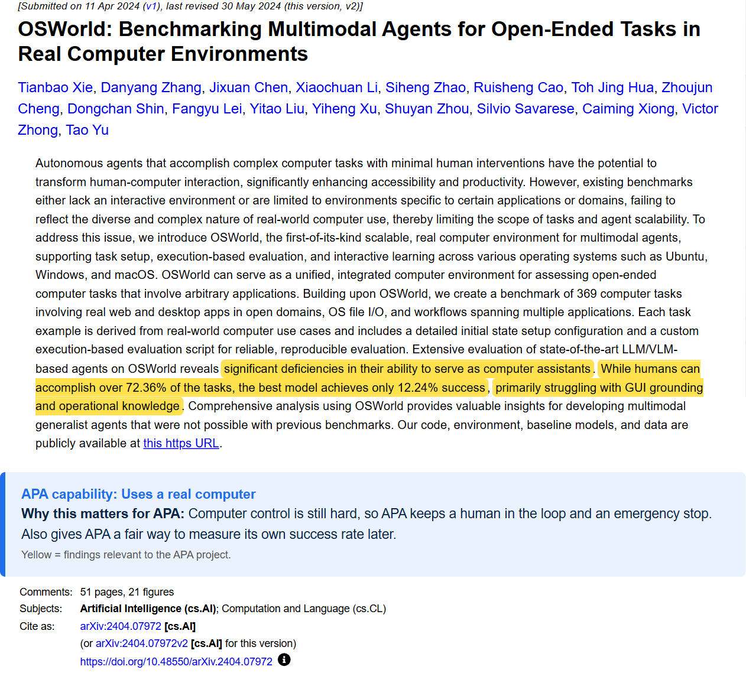

7. Meurisch et al.: Helps without being asked
Meurisch, C., Mihale-Wilson, C. A., Hawlitschek, A., Giger, F., Müller, F., Hinz, O., & Mühlhäuser, M. (2020). Exploring user expectations of proactive AI systems. Proc. ACM IMWUT, 4(4), 1–22.
Link: https://doi.org/10.1145/3432193
Full PDF: ACM Digital Library: open the link and sign in with your university account if needed.
What it is | A real-life study of 272 people asking how much they want an AI to step in without being asked.
Key finding | 3,168 responses: the right amount of proactivity depends on the person and the situation, so it should be adjustable.
Why it matters for APA | APA speaks up on its own (urgent emails, focus nudges). This supports letting users tune how pushy APA is: threshold, cooldown and daily cap.

Highlighted abstract:
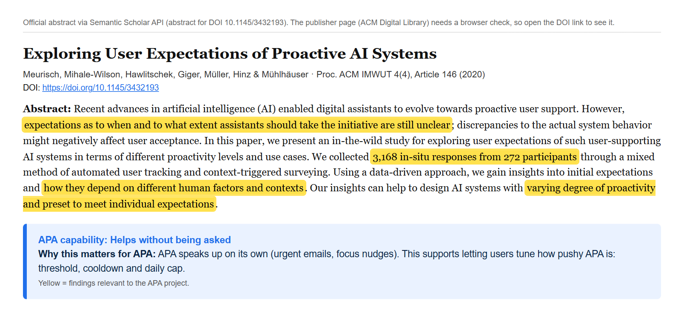
Abstract shown from Crossref/Semantic Scholar metadata, because the ACM page blocks automated screenshots.

8. MemGPT: Remembers you
Packer, C., Wooders, S., Lin, K., Fang, V., Patil, S. G., Stoica, I., & Gonzalez, J. E. (2023). MemGPT: Towards LLMs as operating systems. arXiv.
Link: https://arxiv.org/abs/2310.08560
Full PDF: https://arxiv.org/pdf/2310.08560
What it is | Gives an AI long-term memory by managing it like a computer's operating system manages RAM and disk.
Key finding | Handles very long documents and remembers users across many chat sessions.
Why it matters for APA | A real personal assistant should remember you (preferences, past tasks, contacts). Reference design for adding memory to APA, behind a privacy boundary.

Highlighted abstract:
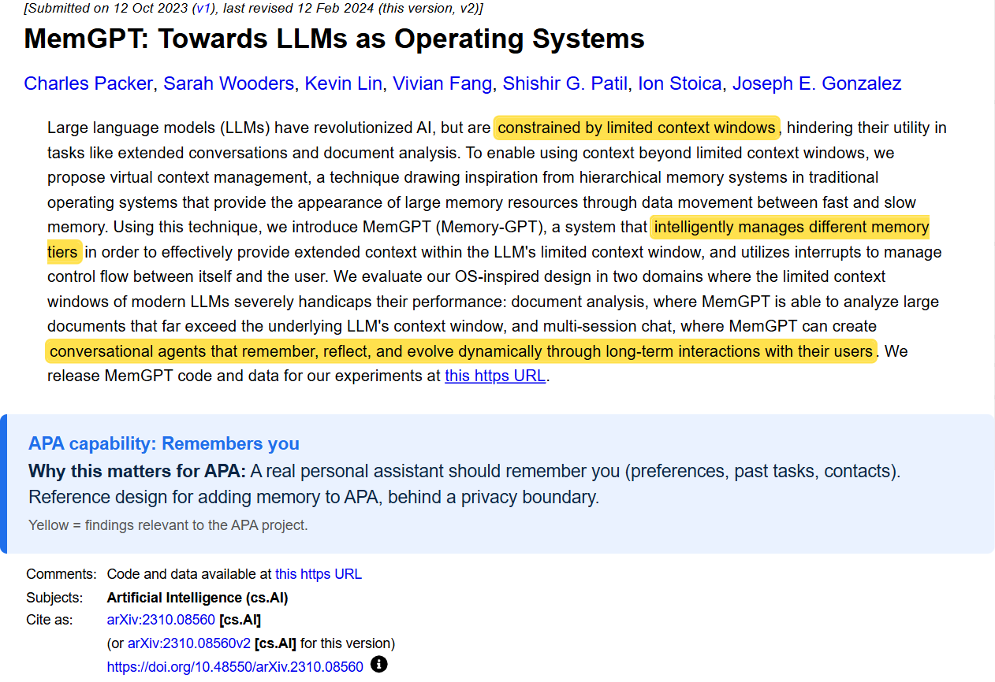

9. Greshake et al.: Stays safe from tricks
Greshake, K., Abdelnabi, S., Mishra, S., Endres, C., Holz, T., & Fritz, M. (2023). Not what you've signed up for: Compromising real-world LLM-integrated applications with indirect prompt injection. AISec '23, 79-90.
Link: https://arxiv.org/abs/2302.12173
Full PDF: https://arxiv.org/pdf/2302.12173
What it is | Shows attackers can hide instructions in web pages, emails or documents that an AI later reads and obeys.
Key finding | Real AI apps were tricked into data theft and unwanted actions; good defences are still lacking.
Why it matters for APA | APA reads emails and the screen, and both can hold attacker text. That's why APA's prompt says screen text is information, never instructions, and sensitive actions need confirmation.

Highlighted abstract:
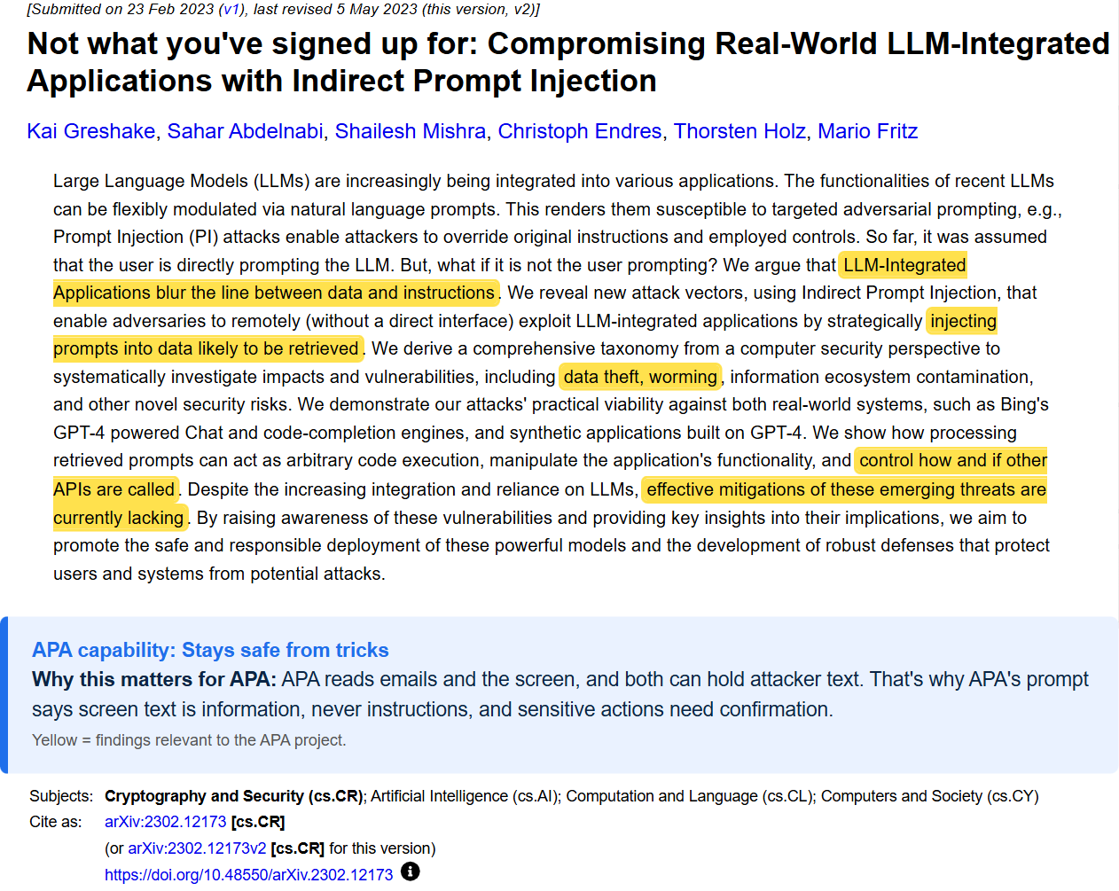

10. Lau et al.: Respects privacy
Lau, J., Zimmerman, B., & Schaub, F. (2018). Alexa, are you listening? Privacy perceptions, concerns and privacy-seeking behaviors with smart speakers. Proc. ACM HCI, 2(CSCW), 1–31.
Link: https://doi.org/10.1145/3274371
Full PDF: ACM Digital Library: open the link and sign in with your university account if needed.
What it is | Diary and interview study of 17 smart-speaker users and 17 non-users about privacy.
Key finding | Users had few worries but didn't fully understand the risks, and rarely used privacy controls.
Why it matters for APA | APA hears your voice and sees your screen and inbox. Users won't fix privacy in settings, so APA builds it in: audio sent only when you speak, credentials out of code, private data local.

Highlighted abstract:
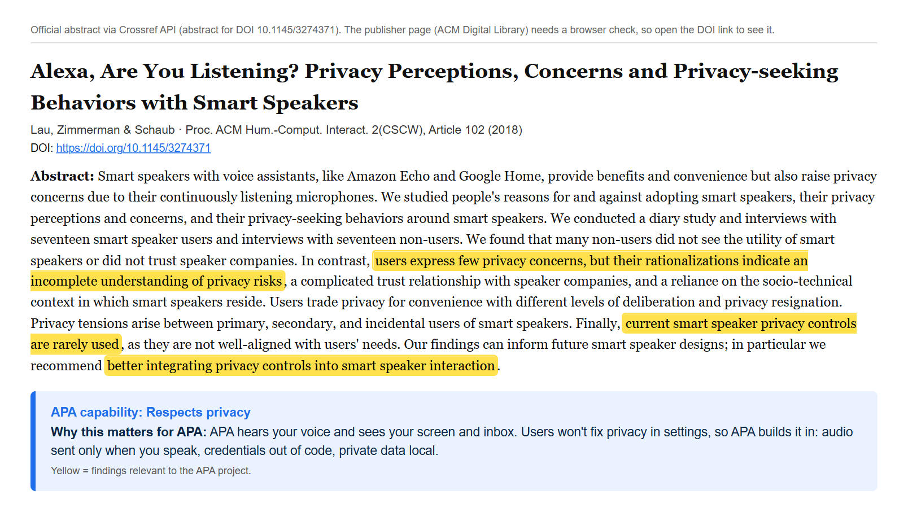
Abstract shown from Crossref/Semantic Scholar metadata, because the ACM page blocks automated screenshots.

11. Generative Agents: Self-monitoring and reflection
Park, J. S., O'Brien, J. C., Cai, C. J., Morris, M. R., Liang, P., & Bernstein, M. S. (2023). Generative agents: Interactive simulacra of human behavior. UIST 2023.
Link: https://arxiv.org/abs/2304.03442
Full PDF: https://arxiv.org/pdf/2304.03442
What it is | AI agents that keep a diary of everything they experience, turn those memories into higher-level reflections, and use them to plan what to do next.
Key finding | Removing memory, reflection or planning made the agents clearly less believable; all three parts matter.
Why it matters for APA | Blueprint for APA's future local brain: remember what it did, reflect on it and plan with it, so APA can monitor and improve itself. Note: this is self-monitoring, not human-style self-awareness.

Highlighted abstract:
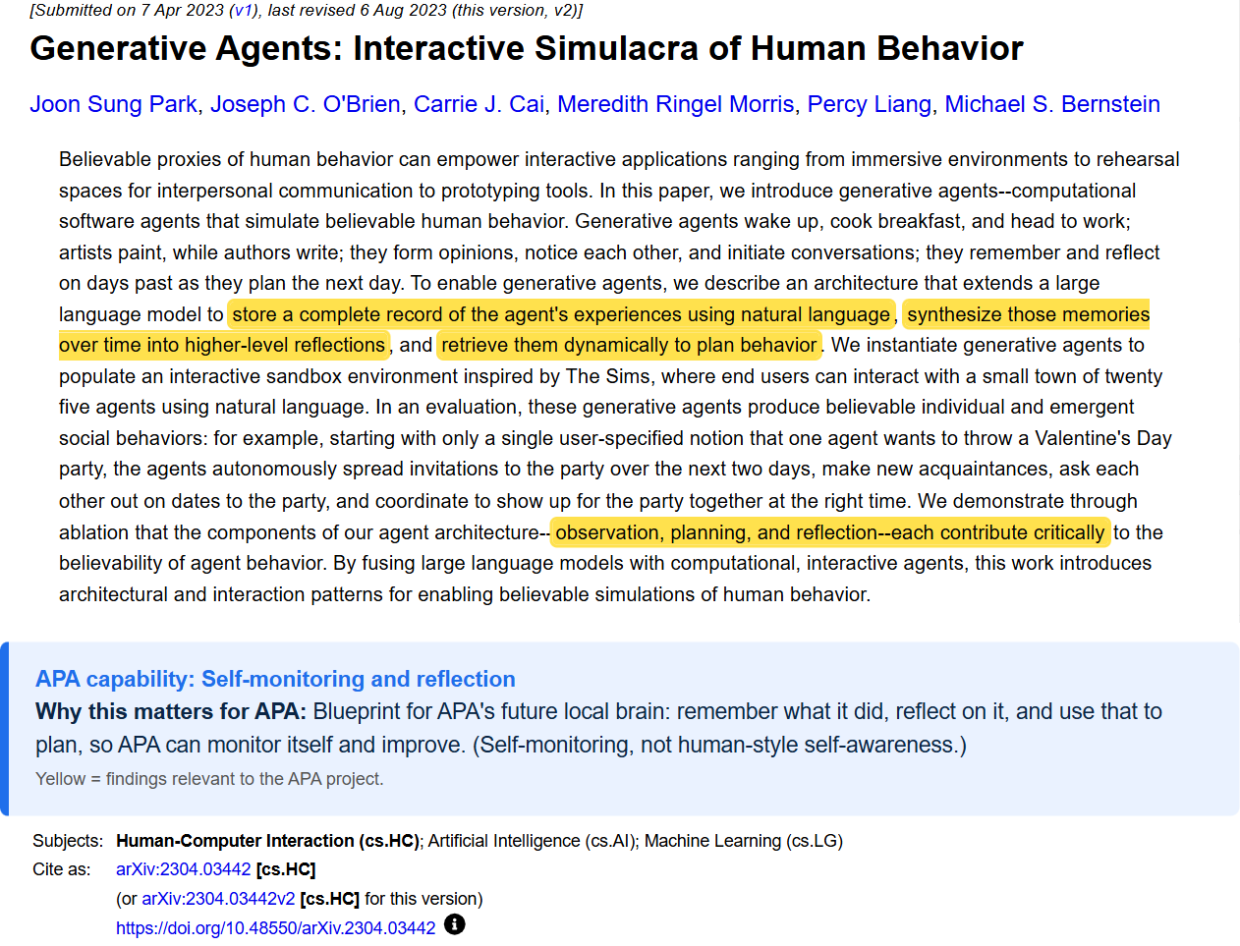

12. Personal LLM Agents survey: All-in-one personal assistant
Li, Y., Wen, H., Wang, W., Li, X., Yuan, Y., Liu, G., Liu, J., Xu, W., Wang, X., Sun, Y., Kong, R., Wang, Y., Geng, H., Luan, J., Jin, X., Ye, Z., Xiong, G., Zhang, F., Li, X., . . . Liu, Y. (2024). Personal LLM agents: Insights and survey about the capability, efficiency and security [Preprint]. arXiv. https://doi.org/10.48550/arXiv.2401.05459
Link: https://arxiv.org/abs/2401.05459
Full PDF: https://arxiv.org/pdf/2401.05459
What it is | A large survey of AI agents that are tied to your personal data and devices and help with everyday life, written with input from domain experts.
Key finding | Old assistants (Siri-style) were limited; LLM-based personal agents are expected to become a major software paradigm. Key challenges: capability, efficiency and security.
Why it matters for APA | Confirms APA's research area exists: an all-in-one personal assistant. APA's features map onto the survey's core abilities (task execution, sensing context, memory), and its challenges match ours (local vs cloud efficiency, security).

Highlighted abstract:


